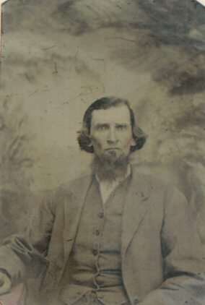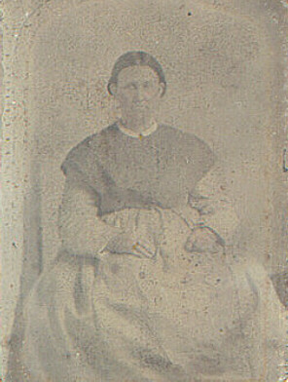

Joshua Jameson and Mary Bowen Hunt Jameson
Date unknown, original pictures on tintype

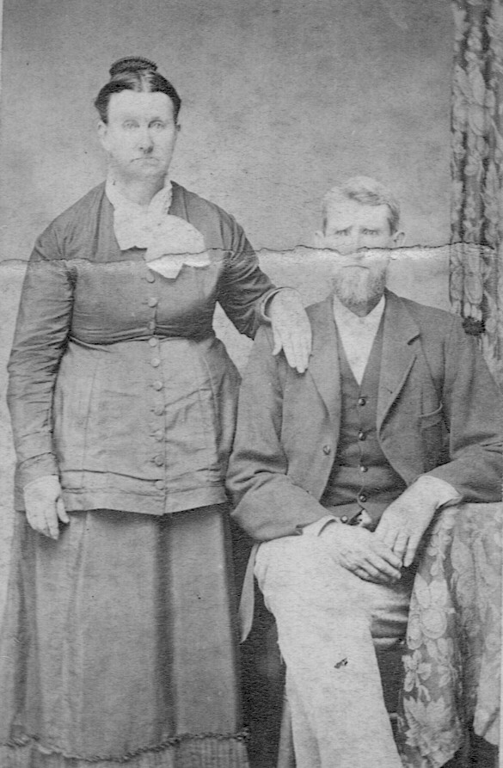
Joshua Jameson and Mary Bowen Hunt
Date unknown
Pictures from the photo album of Minnie Jameson Orr

